Association Rules and Lift Analysis
Task 3
Kiara Angelys Gänger
Western Governor University
D212 | Data Mining II

Scenario 1
One of the most critical factors in customer relationship management that directly affects a company’s long-term profitability is understanding the customers. When a company can better understand its customers’ characteristics, it is better able to target products and marketing campaigns for customers, resulting in better profits for the company in the long term.
You are an analyst for a telecommunications company that wants to better understand the characteristics of its customers. You have been asked to perform a market basket analysis to analyze customer data to identify key associations of your customer purchases, ultimately enabling better business and strategic decision-making.

Part I: Research Question

Purpose of Report

Question
What combinations of items do customers frequently purchase together?

Goal
My goal is to identify patterns in customer purchases that can inform future marketing strategies and product placement in the company’s online store.

Part II: Market Basket Justification

Reasons For Market Basket Analysis

Explain How Market Basket Analyzes the Data:
Market basket analysis (MBA) identifies relationships between items that customers frequently purchase together. It helps companies better understand customer buying behaviors by examining associations between products (Staff, 2024). Market Basket will analyze the data by identifying the customer’s purchase history. Apriori algorithm will then extract the items that are frequently bought together.
My expected outcomes will be association rules that provide insights into item combinations. For example, if a customer buys a USB-C charger, they may also buy a USB-C to HDMI adapter. These item relationships will help companies on how to display and place items in stores. Since those two items are frequently bought together, it would make sense to place them next to each other.

Example of Transactions:
One example of a transaction in the dataset is row 249:
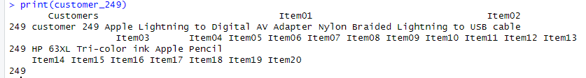
This customer has purchased in either one trip or multiple a Apple Lightning to Digital AV Adapter, Nylon Braided Lightning to USB cable, HP 63XL Tri-color ink and a Apple Pencil.

Assumption of Market Basket Analysis
One fundamental assumption of market basket analysis is that the presence of one item in a transaction increases the likelihood of another item being included in the same transaction (R Market Basket Analysis using Apriori Examples, 2018). This assumption helps identify associations between products based on historical purchase data, which can help businesses understand product pairings and can design promotion. For example, if 70% of customers who buy Beer also buy diapers, they can run a buy a six pack and get diapers 50% off.

Part III: Data Preparation and Analysis

Prepare and Perform Market Basket Analysis
For this section I followed the Panopto video presentation provided by Dr.Kesselly Kamara, B.Sc., MSIA, MSNM, DCSBDA​ (Kamara, 2023)

Transform the Data
To prepare the data to make it suitable to transform I took the following steps:
I loaded the tidyverse and arules library into R, this will provide me with the back bones needed to perform my analysis. I then loaded the tmb dataset and gave it a quick inspection. After reviewing it, I noticed that every other row was blank, so I went ahead and dropped those rows and reset the number of the rows to read 1,2,3 and not 2,4,6. I then wanted to get a better understanding of what each item was. By looking at the chart I assumed that there were only 20 distinct items, hints the columns being named item01, item02 and so on. After pulling the distinct items it came back with 120 and one of those was blank.
# Part C1
#Step 1: Load library
library(tidyverse)
library(arules)

# Step 2: Load the data set
tmb <- read.csv(
"C:/Users/kiara/OneDrive/WGU MSDA/D212 Data Mining II/Task 3/teleco_market_basket.csv"
)
View(tmb)

# Step 3: Remove completely empty rows from the set
tmb <- tmb[!apply(tmb, 1, function(row)
all(is.na(row) | row == "")), ]
# Reset row numbers so they go 1,2,3
rownames(tmb) <- NULL

# Step 4: Find all the different Items in the data set
all_items <- as.vector(as.matrix(tmb))
distinct_items <- unique(all_items)
distinct_items
Now to the transformation; To transform the data to make it suitable for market basket analysis I:
I added a transaction ID column, this will help me properly structure the data before converting it. Then I flattened the items into a single column and removed the blank item giving me a total of 119 items. Then I used the as(transactions, "transactions") command to transform the data into a transaction. Once I verified that worked, I converted it to a matrix to form it into a table and save a csv copy. Which is attached as basket.csv
tmb <- tmb %>%
mutate(TransactionID = row_number())

tmb_long <- tmb %>%
pivot_longer(cols = starts_with("Item"), values_to = "Item") %>%
filter(Item != "")

transactions <- as(split(tmb_long$Item, tmb_long$TransactionID), "transactions")
inspect(transactions[1:5])

# Convert transactions to matrix and then to data frame
basket_matrix <- as(transactions, "matrix")
basket <- as.data.frame(basket_matrix)

# View first few rows of the data frame as a table
head(basket)

write.csv(
basket,
"C:/Users/Kiara/OneDrive/WGU MSDA/D212 Data Mining II/Task 3/basket.csv",
row.names = FALSE
)
View(basket)
Example of table:
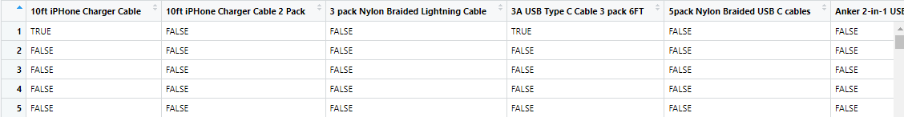

Apriori Algorithm Code Execution and Screenshots
The code I used to run the Apriori algorithm to generate association rules (Kamara, 2023):
# Part C2
# Run Apriori algorithm on transactions
arules <- apriori(
basket,
control = list(verbose = F),
parameter = list(
supp = 0.008,
conf = 0.4,
minlen = 2
)
)

# Remove redundant rules
redundant_r <- is.redundant(arules)
refined_arules <- arules[!redundant_r]

#inspect top rules
inspect(head(sort(
refined_arules, by = "lift", decreasing = T
), 10))
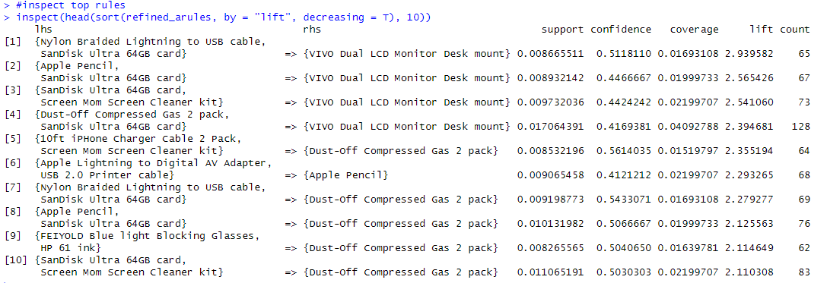
summary(refined_arules)
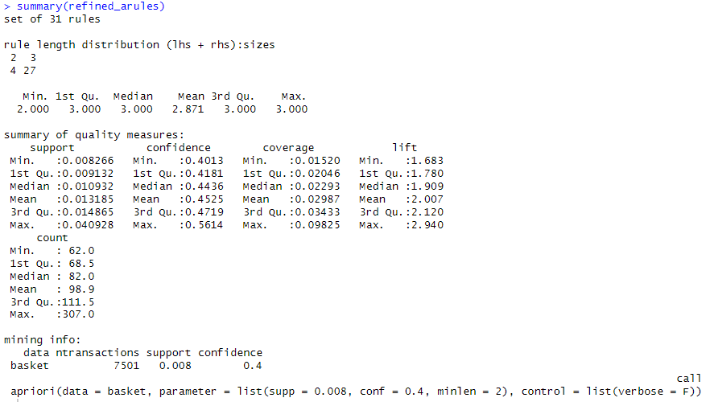

Provided Values of the Association Rules Table
The values of the association rules table is broken down as follows:
Rule | Antecedents | Consequents | Support | Confidence | Lift | Count
1 | Nylon Braided Lightning to USB cable, SanDisk Ultra 64GB card | VIVO Dual LCD Monitor Desk mount | 0.0087 | 0.5118 | 2.94 | 65
2 | Apple Pencil, SanDisk Ultra 64GB card | VIVO Dual LCD Monitor Desk mount | 0.0089 | 0.4467 | 2.56 | 67
3 | SanDisk Ultra 64GB card, Screen Mom Screen Cleaner kit | VIVO Dual LCD Monitor Desk mount | 0.0097 | 0.4424 | 2.51 | 73
4 | Dust-Off Compressed Gas 2 pack, SanDisk Ultra 64GB card | VIVO Dual LCD Monitor Desk mount | 0.0170 | 0.4170 | 2.40 | 128
5 | 10ft iPHone Charger Cable 2 Pack, Screen Mom Screen Cleaner kit | Dust-Off Compressed Gas 2 pack | 0.0085 | 0.5614 | 2.35 | 64

The Apriori Algorithm’s Top 3 Relevant Rules
The top three relevant rules are:

Part IV: Data Summary and Implications

Summarize Data Analysis

Significance of Support, Lift, and Confidence:
Support: Indicates the proportion of transactions in which items are bought together. This is important because it shows me how frequently these two items are paired. The more they are bought together, the more likely they should be paid attention to for marketing or product placement ideas. For example, Nylon Braided Lightning to USB cable, SanDisk Ultra 64GB card => VIVO Dual LCD Monitor Desk mount has a support of 0.0087. This means this combination of items happens in about .87% of the transactions or 65 out of 7501 transactions.
Confidence: Tells us how likely it is for customers to buy one item if they buy another, in this case VIVO Dual LCD Monitor Desk mount. When items like USB cable and SanDisk card are bought according to rule 1 there is a 51% chance of the desk being bought too.
Lift: Lift measures the strength of the association compared to random chance. For example, the first rule has a lift of 2.94, meaning customers are almost 3 times more likely to purchase the monitor desk mount when they buy the USB cable and SanDisk card than they would if the purchases were random. Lift is major because it highlights which item pairs are worth focusing on, especially when it's that high.

Practical Significance of Findings:
The practical significance of these findings is the strong association between certain items, which can be used to inform marketing and product placement strategies. Like, the fact that " Nylon Braided Lightning to USB cable" and " SanDisk Ultra 64GB card" with the "VIVO Dual LCD Monitor Desk mount" suggests that customers who purchase tech accessories like cables and memory cards are also likely to invest in more substantial tech gear, like monitor mounts. Rules 2 and 3 conform these findings. By promoting these items together in targeted ads or offering discounts on them as a package deal can help enhance customer engagement and encourage purchases.

Recommended Course of Action:
My recommendation course of action based on this analysis, is to create Product Bundles, Improve Product Placement, Inventory Management and Targeted marketing. For example, we can create bundles of the USB cables, and memory cards. Create a Buy one get one a certain percentage off sale. Making sure those items are always in stock, placing them next to each other at stores or side by side on the online store and when creating ads have those items together. This will help the company make the best of the two items partnership and improve sales with something that is already working.

Part V: Attachments

Panopto Video

Link: Ganger, Kiara Task 3 D 212 Take 2

References
Kamara, K. D. (2023). Data Mining II - D212 Task 3 R. (W. G. University, Producer) Retrieved from WGU Panopto: https://wgu.hosted.panopto.com/Panopto/Pages/Viewer.aspx?id=5674b196-a9f1-4e85-a322-af0000021f3f&query=d212%20basket%20analysis
R Market Basket Analysis using Apriori Examples. (2018, August 21). Retrieved from DataCamp: https://www.datacamp.com/tutorial/market-basket-analysis-r
Staff, E. (2024, January 17). Market Basket Analysis. Retrieved from DevX: https://www.devx.com/terms/market-basket-analysis/

